Riphah International University

Gulberg greens Campus

Submitted by : Mahnoor Ahmed
Sap id : 80207
Submitted to : Mam Nayab Khalid
Lab # 04

Task no.1

Write a Java program to store the marks of five students using an ArrayList<Integer>. Use an Enhanced For Loop to display all the marks, calculate and display the total and average marks, and find and display the highest mark.
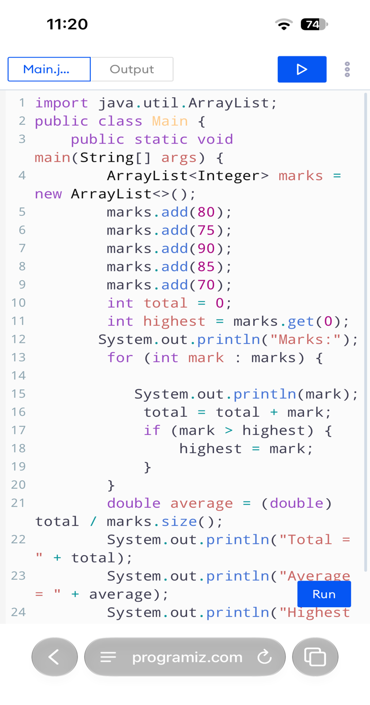
Program:
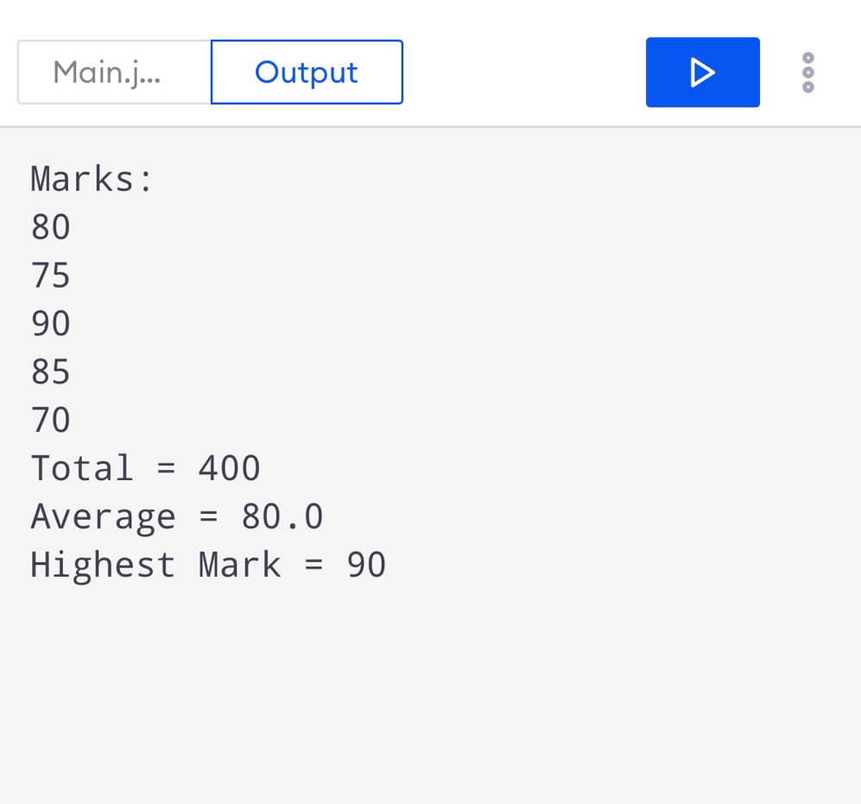
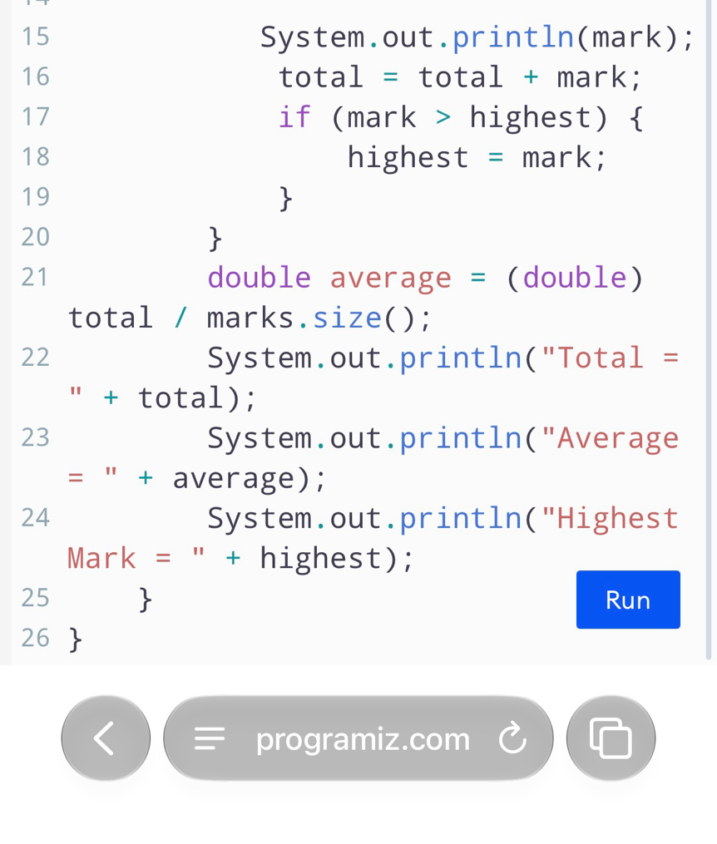
Result:
Task no . 2
Write a Java program that takes a student's name as a String and performs basic string processing. The program should display the original name, its uppercase and lowercase forms, the total number of characters, the first character using charAtO, and whether the name contains the letter "a".

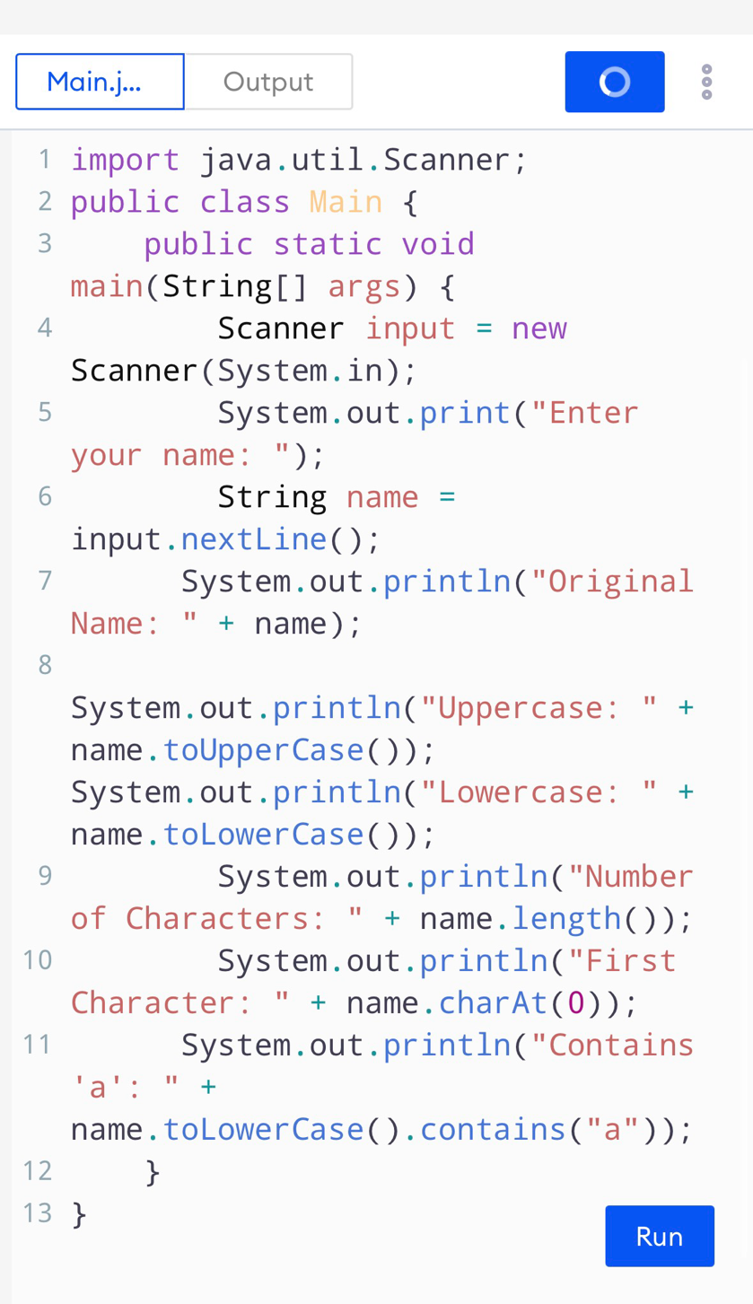
Program:
Result :

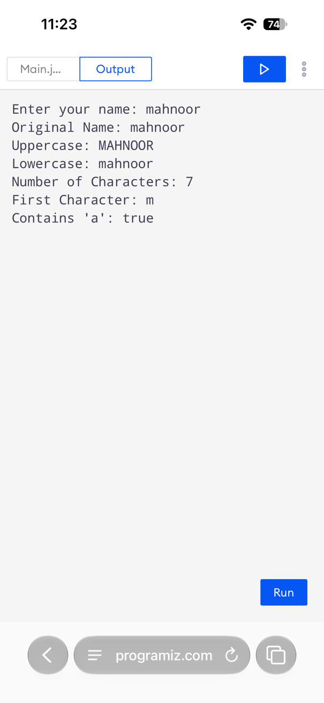

Task no .3
Write a Java program that takes a single character from the user and stores it in a char variable. Display the entered character and its corresponding integer/Unicode value. The program should also determine whether the character is a digit, an uppercase letter, or a lowercase letter, and display the appropriate message.

Program:
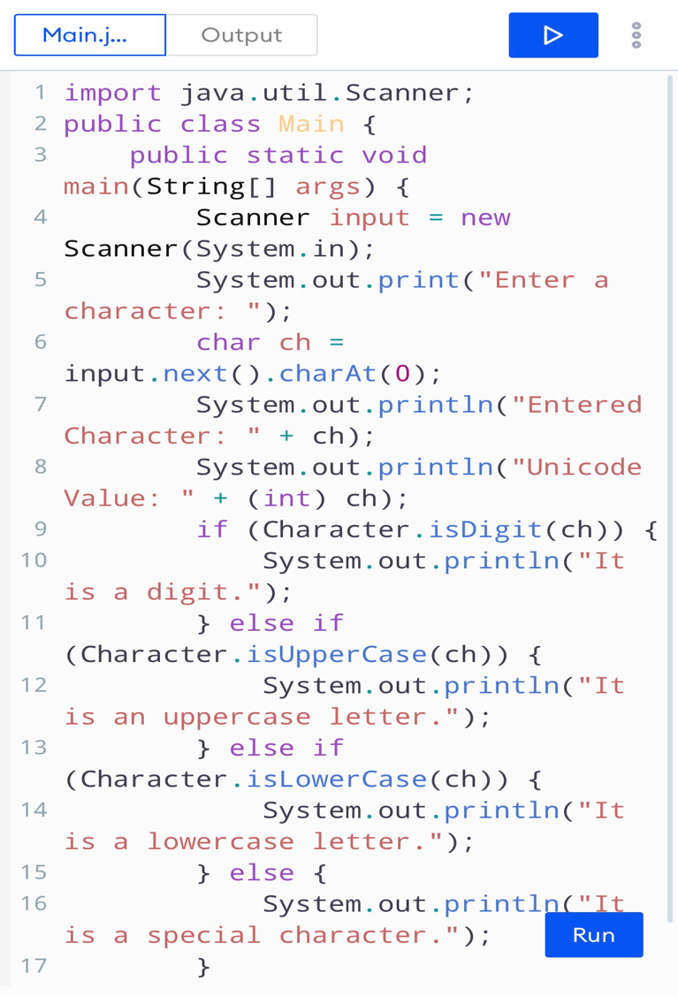
Result:


